1. Consider the following TCP transmission scenarios between hosts A and B. The first byte of A is numbered as 15375. The first byte of B is numbered as 25125. Write the corresponding packet field’s information of each packet.
   1. Sequence number
   2. Acknowledgement number
   3. Acknowledgement flag value
   4. SYN flag value
   5. FIN flag value

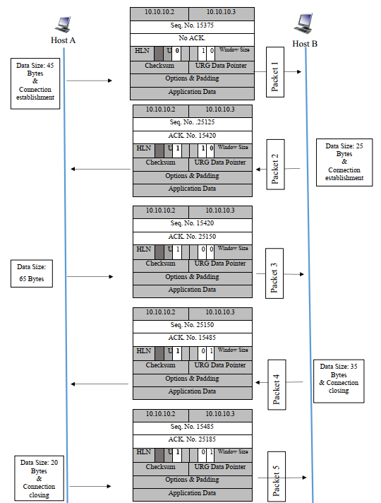

# 2. Consider an instance of TCP’s Additive Increase Multiplicative Decrease (AIMD) algorithm where the window size at the start of the slow start phase is 2 MSS and the threshold at the start of the first transmission is 8 MSS. Assume that a time out occurs during the fifth transmission. Find the congestion window size at the end of the tenth transmission.